

**JUDGE FROG**

User Manual

***V2.0***

**5/3/2015**

# Revision History

|  |  |  |
| --- | --- | --- |
| Version | Changes | Edited |
| 1.0 | * Initial Draft | March 15, 2015 |
| 1.1 | * System Walkthrough | April 23, 2015 |
| 2.0 | * Draft Revisions | May 3, 2015 |

# Revision Sign-Off

By signing the following, the team member is stating that he has read the entire document and has verified that the information contained within this document is accurate, relevant to the project, and void of errors.

|  |  |  |
| --- | --- | --- |
| Name | Signature | Date Signed |
| Brice Boula |  |  |
| Collin Duncan |  |  |
| David Tomlinson |  |  |
| Landon Westrom |  |  |

# Table of Contents

Revision History ii

Revision Sign-Off ii

Table of Contents iii

1. Introduction 1

1.1 Purpose 1

1.2 Project Overview 1

1.3 Overview 1

2. System Components 2

2.1 System Components 2

2.1.2 Compatible Web Browser 2

3. System Walkthrough 3

3.1 System Overview 3

3.1.1 Admin Panel 3

3.1.2 Searching the Database 8

3.1.3 Graph Analysis 10

4. Glossary of Terms 11

# Introduction

## 1.1 Purpose

The purpose of this document is to provide the user with a complete overview and explanation of all aspects of the Judge Frog system. This manual will cover an overview of the required system components and a detailed walk through of the system.

## 1.2 Project Overview

Every year, there are thousands of cases involving human trafficking in dozens of courts across the United States. With data from the cases scattered across different judicial districts, it can be difficult to analyze a large amount of cases. Our supporting clients have received a grant from the National Institute of Justice to help fulfill the analysis needed of the vast amount of human trafficking crime in the United States. Judge Frog, a 2014-2015 capstone project, consists of a web application that no one has achieved before to allow the public to tap into this vast amount of data for visual and textual analysis.

## 1.3 Overview

This document includes the following sections.

**Section 2 – System Components:** Lists and describes the required components for operating Judge Frog web application.

**Section 3 – System Walkthrough:** Provides walkthroughs of the features that are provided by the system.

**Section 4 – Glossary of Terms:** Includes a list of abbreviations and their technical terms and their associated definitions.

# System Components

## 2.1 System Components

Judge Frog is comprised of two components; Judge Frog web application and a compatible web browser.

**2.1.1 Judge Frog Web Application**

The web application is hosted on a server that can be accessed by three different domains; humantraffickingdata.org, humantraffickingdata.net, and humantraffickingdata.com.

### 2.1.2 Compatible Web Browser

* Internet Explorer version 11 or higher
* Google Chrome version 40 or higher
* Mozilla Firefox Version 33 or higher
* Safari version 5 or higher

# System Walkthrough

## 3.1 System Overview

The user will be presented with the following options when accessing the web application.

### 3.1.1 Admin Panel

Only authorized users may access the admin panel.

#### 1. Case Management

1. Upload
   1. Select the “CSV file to upload” button and choose the desired CSV docket file of human trafficking cases to upload.
   2. Select the submit button to proceed for cases to be inserted into database.
      1. The user will be provided with a receipt message indicating the number of records inserted or an error message if no cases were inserted.
2. Create and Edit
   1. Download
      1. Select the button to download the most current data from the database that will be saved in CSV file format (Refer to figure A.1)
   2. View “All” and “Incomplete” Cases
      1. By default, all the cases present in the database will be displayed (refer to figure A.2)
      2. To view all the incomplete and or pending approval cases, click on the “incomplete” tab. (refer to figure A.3)
   3. Add New Case
      1. Select the button displayed to proceed to add a new case (refer to figure A.4)
      2. Complete the case fields as necessary (Case name and case number are required)
      3. Press the button “submit” to add the case to the database
   4. Edit and Delete Case
      1. To edit a case, click on the edit button under the “Action” column (refer to figure A.5)
      2. To delete a case, click on the delete button under the “Action” column (refer to figure A.6)

Figure A – Case Creation

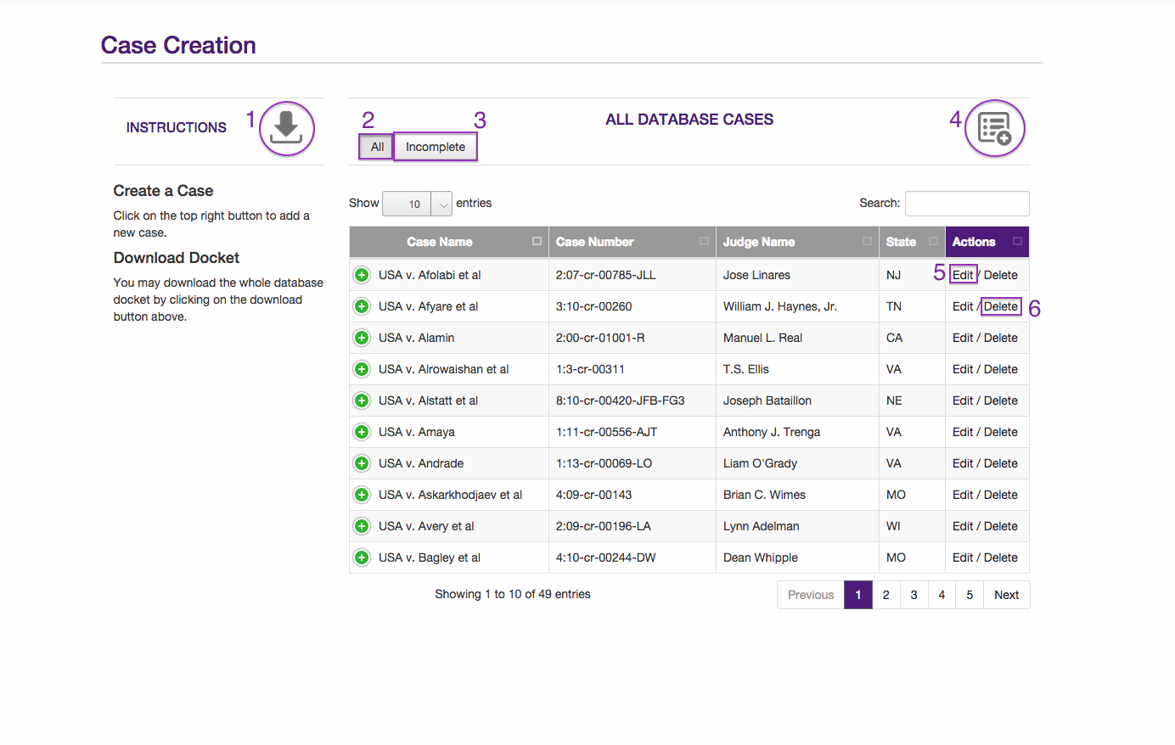

* 1. Edit Case and Defendant
     1. Add a new defendant by selecting the add new defendant button (refer to figure B.1)
     2. Complete the defendant fields as necessary (defendant last name and charge date fields are required)
     3. To edit a defendant, click on the edit button under the “Action” column (refer to figure B.2)
     4. To delete a defendant, click on the delete button under the “Action” column (refer to figure B.3)
     5. Each defendant the user adds or deletes to the case the “number of defendants” field will increment or decrement accordingly (figure B.4)

Figure B – Edit Case

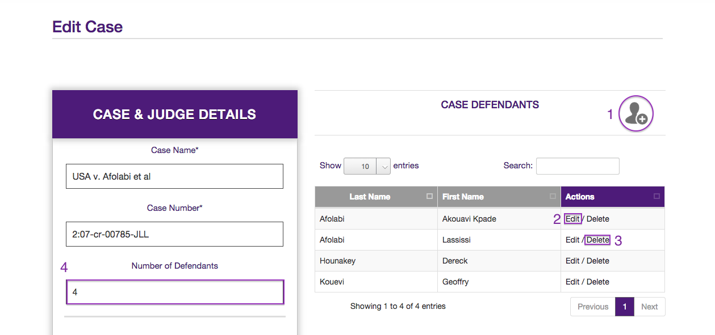

* 1. Submit Case for Review
     1. Access the desired case from the incomplete tab. The user will be displayed the “Cases Pending Completion” section (refer to figure A.3).
     2. Select “edit” for the desired case to be submitted for review (refer to figure A.5).
     3. At the button of the page of the case. Select the checkbox “Submit Case for Review?” (refer to figure C.1).
     4. Select submit to finalize and forward that case for the administrator to review the case (refer to figure C.2).

Figure C – Submit Case

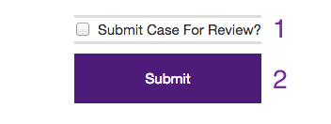

* 1. Review (admin access only)
     1. Select the desired case to review from the case pending review table (refer to figure D.2).
     2. If case information is successfully inputted, then select the airplane icon to submit the case into the data table in the database for users to search the case (refer to figure D.1).
     3. If the case is incorrect the admin can select “edit” to go back and edit the case (refer to figure D.4).
     4. If the admin chooses to delete the case all together from the Cases Pending Completion table in the database, the admin will select delete (refer to figure D.3).

Figure D – Review Case

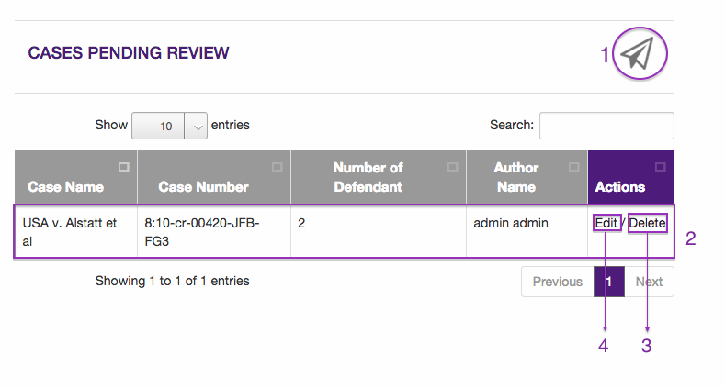

#### 2. User Management

1. Create a user by completing user fields (all fields are required).
   1. Password shall be 6 characters or more.
   2. Privilege Access Level (refer to figure E.1).
2. Delete a user by selecting “delete” of the according user (refer to figure E.2).

Figure E – Manage Users

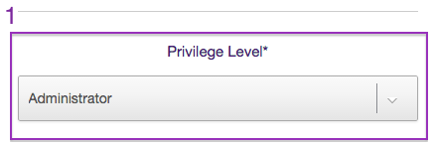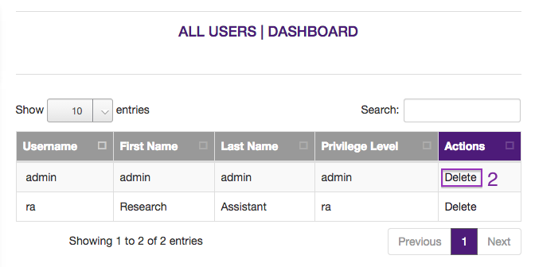

|  |  |  |
| --- | --- | --- |
| Feature | Admin | Research Assistant |
| Upload | X |  |
| Download | X | X |
| Create Case | X | X |
| Edit All Cases | X |  |
| Edit Incomplete Case | X | X |
| Delete Case | X |  |
| Review | X |  |
| User Management | X |  |

### 3.1.2 Searching the Database

1. Select from 47 search variables from 9 categories to filter your search results (refer to figure F.5).
2. Submit search by pressing the magnifying glass (refer to figure F.1).
3. Select a case to view from the case table dashboard (refer to figure F.4).
4. A modal window will appear for the case selected (refer to figure G).
5. By default the case will be filtered according to the criteria entered for the search. Toggle the “Filtered Results” button at the top right to view all results of the selected case (refer to figure F.1).
6. After the user has completed a successful search. The user will select the “Analyze” button. This button will present the user with a separate page that will contain the last search results the user received (refer to figure F.3).
7. To clear your previous search parameters select the refresh button (refer to figure F.2).

Figure F – Search

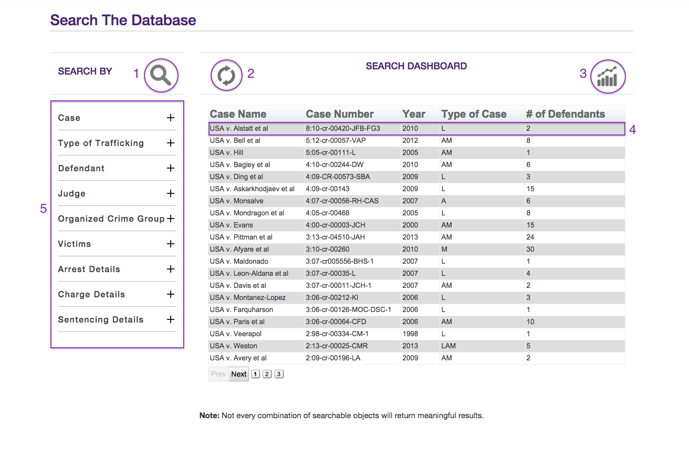

Figure G – Search Modal

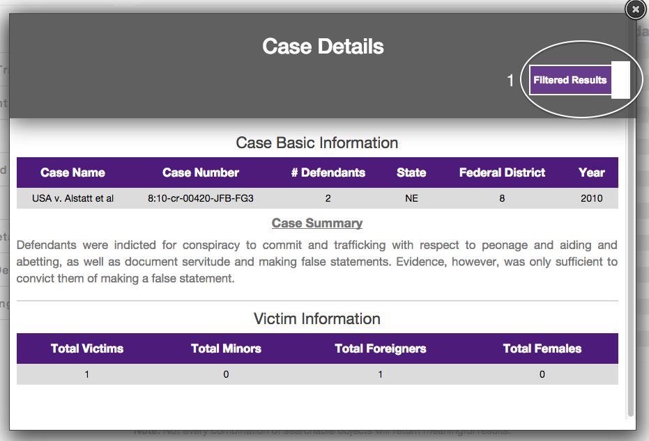

### 3.1.3 Graph Analysis

1. Within the graph menu, select the desired graph for analysis (refer to figure H.1).
2. Within the customize menu, select the desired dependent and independent variables for the selected chart (refer to figure H.2).
3. All the search parameters queried by the user are available at the user’s discretion under the “Search Parameters” tab (refer to figure H.3).
4. To generate graph, select the graph button at the top (refer to figure H.4).
5. The graph will display in the highlighted region (refer to figure H.6).
6. To reset the graph parameters, select the refresh button (refer to figure H.5).

Figure H – Analyze

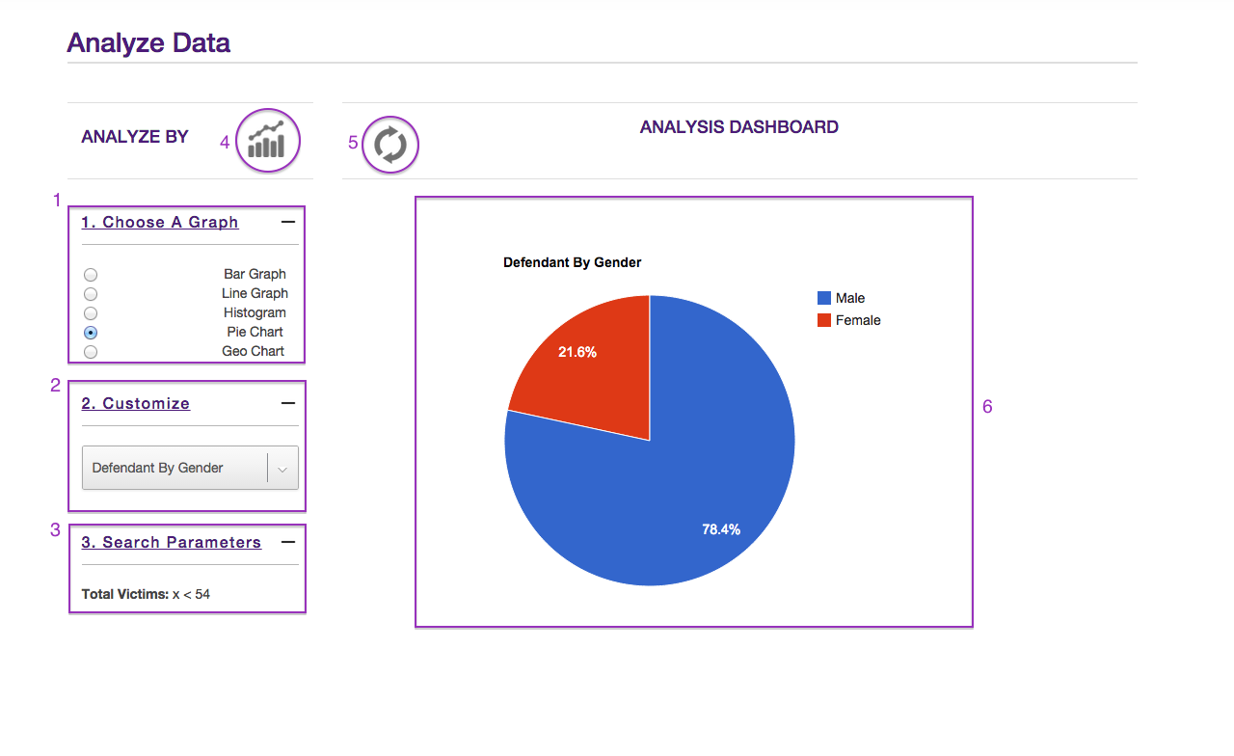

# Glossary of Terms

**CSV File** **–** A CSV file or a Coma Separated Values file also sometimes called Character-Separated Values file stores tabular data (numbers and text) in plain-text form. In this case, the data in the file ought to be in a valid and acceptable form to be uploaded via the upload portal.

**Filtered Results** **–** Case details displayed in the modal window are filtered by default. In other words, the details shown are from the search parameters selected under the 9 different categories.

**Modal** – A popup window that’s populated by case details.

**Search Parameters –** criteria chosen by the user to query the database for cases.